**Project Report**

For

A Nonlinear Approach to Missing Data Imputation Using Ground Truth Feature Modeling

Prepared by

|  |  |  |
| --- | --- | --- |
| **Specialization** | **SAP ID** | **Name** |
| Btech CSE(H) AI/ML | 500090961 | Sidhant Tomar |



School Of Computer Science

UNIVERSITY OF PETROLEUM & ENERGY STUDIES,

DEHRADUN- 248007. Uttarakhand

Table of Contents

|  |  |
| --- | --- |
| **Topic** | **Page No** |
| Problem Statement | 3 |
| Introduction | 3 |
| Methodology | 4 |
| Code | 5 |
| Project Findings | 19 |
| Conclusion | 19 |

# Problem Statement

This project aims to develop and evaluate a novel approach to missing data imputation for classification tasks using polynomial regression. The goal is to accurately estimate missing values in incomplete features of the Pima Indians Diabetes Database, ultimately improving the performance of machine learning models for predicting diabetes in patients.

# Introduction

Missing data is a common challenge in many real-world datasets, and can significantly impact the performance of machine learning models. Imputation techniques aim to estimate and fill in these missing values, allowing for the analysis of complete datasets. Traditional imputation methods, such as mean or median substitution, often fail to capture the underlying relationships between features, leading to biased or inaccurate predictions.

In this project, I explore a novel approach to missing data imputation for classification tasks. Specifically, I leverage the most complete features in the dataset as "ground truth" variables, and use polynomial regression to model the relationships between these ground truth features and the incomplete features. By fitting polynomial models to each ground truth-incomplete feature pair, I can estimate the missing values in a manner that accounts for potential nonlinear associations.

The dataset used in this study is the Pima Indians Diabetes Database, which contains medical diagnostic records for patients of Indian heritage. My goal is to predict whether a patient has diabetes or not, based on various physiological measurements such as glucose levels, blood pressure, body mass index (BMI), and age. However, this dataset suffers from a significant amount of missing values, making imputation a necessary step before model training.

My approach involves first identifying the most complete features in the dataset, which in this case are 'Glucose', 'BMI', and 'Age'. These features serve as the "ground truth" variables for imputing missing values in the remaining incomplete features, such as 'BloodPressure', 'SkinThickness', 'Insulin', and 'DiabetesPedigreeFunction'. By leveraging the predictive power of the complete features, I aim to estimate the missing values more accurately than traditional imputation techniques.

After imputing the missing values using my proposed method, I train a classification model on the completed dataset to predict the 'Outcome' variable, which indicates whether a patient has diabetes or not. I compare the performance of my approach not having imputing the missing data at all (using the incomplete dataset).

# Methodology

The methodology can be divided into three main stages: data preprocessing, missing value imputation, and classification.

### Data Preprocessing

The Pima Indians Diabetes Database was used as the primary dataset for this study. The dataset contains 768 instances and 9 features: 'Pregnancies', 'Glucose', 'BloodPressure', 'SkinThickness', 'Insulin', 'BMI', 'DiabetesPedigreeFunction', 'Age', and 'Outcome'. The 'Outcome' feature serves as the target variable, indicating whether a patient has diabetes (1) or not (0).

In the preprocessing stage, the dataset was analyzed to identify the most complete features, which would serve as "ground truth" variables for imputing missing values. The features 'Glucose', 'BMI', and 'Age' were found to have the highest completion rates and were selected as the ground truth features.

### Missing Value Imputation

The imputation approach adopted in this project leverages polynomial regression to model the relationships between the ground truth features and the incomplete features. For each incomplete feature, polynomial regression models were built using every possible combination of the ground truth features as independent variables.

A custom-built polynomial regression class, PolyFitter, was implemented with visualization tools to aid in model selection and analysis. This class fitted polynomial models of varying degrees to the input data and provided diagnostic plots for assessing model fit and complexity.

The imputation process followed these steps:

1. For each incomplete feature, create a dictionary to store the polynomial regression models using every combination of ground truth features as independent variables.
2. Train and store the polynomial regression models in the dictionary, using the PolyFitter class.
3. For each instance with a missing value in the incomplete feature: a. If the instance has non-zero values for 'Pregnancies', 'DiabetesPedigreeFunction', or 'Outcome', skip imputation for that instance. b. If the missing value is in one of the ground truth features, use the other ground truth features to predict the missing value using the corresponding polynomial regression models. c. For missing values in other incomplete features, predict the value using each ground truth feature's polynomial regression model, and take the geometric mean of these predictions as the imputed value.

After imputing the missing values using this approach, the dataset was complete and ready for classification.

### Classification

For the classification task, a logistic regression model was employed to predict the 'Outcome' variable. The performance of the logistic regression model was evaluated on two versions of the dataset:

1. The original, incomplete dataset with missing values.
2. The imputed dataset, where missing values were filled using the proposed polynomial regression imputation approach.

The motivation behind evaluating the model on both versions was to assess the impact of the imputation technique on the classification performance. By comparing the results obtained from the incomplete and imputed datasets, the effectiveness of the imputation approach could be quantified.

The logistic regression model was trained and evaluated using appropriate metrics, such as accuracy, precision, recall, and F1-score, on each version of the dataset. This allowed for a direct comparison of the model's performance when trained on the incomplete data versus the imputed data.

# Code:

import pandas as pd

import numpy as np

import matplotlib.pyplot as plt

# Reading the Pima Diabetes dataset.

df = pd.read_csv('diabetes.csv')

df.head()

|  | **Pregnancies** | **Glucose** | **BloodPressure** | **SkinThickness** | **Insulin** | **BMI** | **DiabetesPedigreeFunction** | **Age** | **Outcome** |
| --- | --- | --- | --- | --- | --- | --- | --- | --- | --- |
| **0** | 6 | 148 | 72 | 35 | 0 | 33.6 | 0.627 | 50 | 1 |
| **1** | 1 | 85 | 66 | 29 | 0 | 26.6 | 0.351 | 31 | 0 |
| **2** | 8 | 183 | 64 | 0 | 0 | 23.3 | 0.672 | 32 | 1 |
| **3** | 1 | 89 | 66 | 23 | 94 | 28.1 | 0.167 | 21 | 0 |
| **4** | 0 | 137 | 40 | 35 | 168 | 43.1 | 2.288 | 33 | 1 |

# checking for what

for col in df.columns:

print(col, (df[col] == 0).sum())

Pregnancies 111

Glucose 5

BloodPressure 35

SkinThickness 227

Insulin 374

BMI 11

DiabetesPedigreeFunction 0

Age 0

Outcome 500

#### Choosing what to make the regressor

When we observe the counts of 0 (potential missing values), we see that glucose, BMI and Age all seem to be good candidates to pick as some sort of ground truth value we can use to predict the missing values.

One simple method is to use 3 separate regressors that perform 2d linear/polynomial regression to find the the missing values, then take the geometric mean

sel_cols = ['Glucose', 'BMI', 'Age']

for sc in sel_cols:

fig, axes = plt.subplots(2, 3, figsize=(12, 8))

i = 0

for col in df.columns:

if col == sc or col == 'Outcome' or col == 'Pregnancies':

continue

axes[i // 3][i % 3].scatter(df[sc], df[col], color='red')

axes[i // 3][i % 3].axhline(0, color='black', linewidth=0.5)

axes[i // 3][i % 3].axvline(0, color='black', linewidth=0.5)

axes[i // 3][i % 3].set_title(sc + " vs " + col)

i += 1

plt.tight_layout()

plt.subplots_adjust(top=0.9)

plt.show()

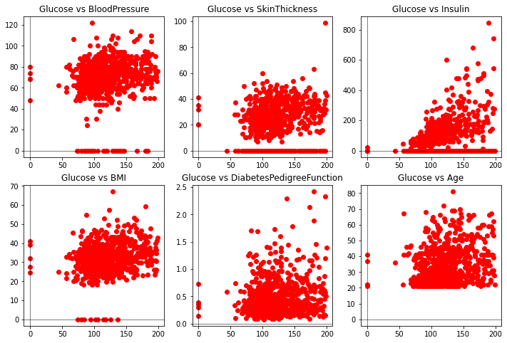

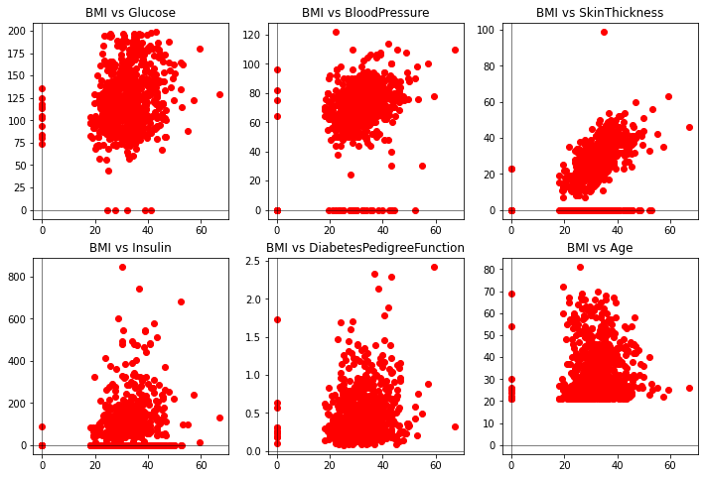

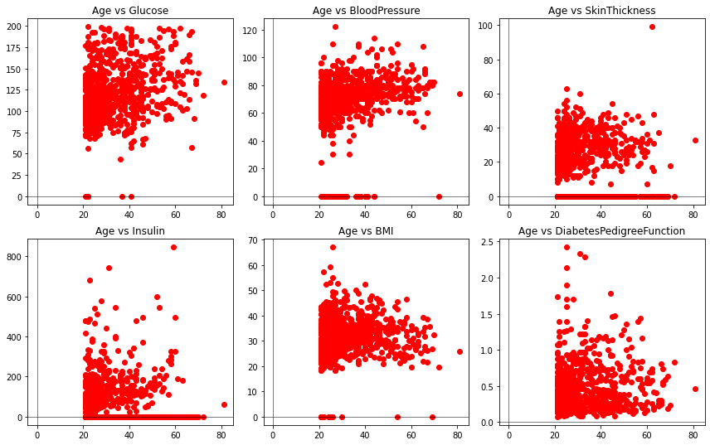

# the polynomial regression library used.

import numpy as np

import matplotlib.pyplot as plt

class BadInputError(Exception):

def __init__(self, message="Bad input error"):

self.message = message

super().__init__(self.message)

class PolyFitter:

def __init__(self, m=15):

self._lim = m

self._X_train = []

self._Y_train = []

self._X_test = []

self._Y_test = []

self.model = []

def split_train_test(self, X, Y, train_ratio=.8):

try:

if (len(X) != len(Y)):

raise BadInputError("dependent and independent variable lengths do not match")

except BadInputError as err:

print(err)

size = int(len(X) * train_ratio)

temp = np.random.choice(len(X), len(X), replace=False)

indices, indices1 = temp[:size], temp[size:]

# Assigning train data

self._X_train = X[indices]

self._Y_train = Y[indices]

indices1 = np.array(indices1)

# Assigning test data

self._X_test = X[indices1]

self._Y_test = Y[indices1]

test_sorted_indices = np.argsort(self._X_test)

train_sorted_indices = np.argsort(self._X_train)

self._X_test = self._X_test[test_sorted_indices]

self._X_train = self._X_train[train_sorted_indices]

self._Y_test = self._Y_test[test_sorted_indices]

self._Y_train = self._Y_train[train_sorted_indices]

return [self._X_train, self._Y_train, self._X_test, self._Y_test]

def making_A(self, m, x):

x = np.array(x)

data = x

L = np.zeros((m+1,m+1))

for i in range(2*m, m-1, -1):

c = 0

for j in range(i, i-m-1, -1):

L[2 * m - i, c] = np.sum(data ** j)

c += 1

return L

def making_B(self,m,y,x):

y = np.array(y)

x = np.array(x)

data=x

L = np.zeros((m+1,1))

for i in range(m, -1,-1):

L[m-i] = np.sum(y*(data**i))

return L

def solve_polyfit(self, A,B,m):

coeffs = np.zeros((m,1))

coeffs = np.linalg.solve(A,B)

coeffs = np.flip(coeffs)

return coeffs

def predict_single(self, x, model= None):

if (model == None):

model = self.model

predicted = 0

for i in range(len(model)):

predicted += model[i] * (x**i)

return predicted

def check(self, X, coeffs=[]):

if len(coeffs) == 0:

coeffs = self.model

def PolyCoefficients(x, coeffs):

o = len(coeffs)

y = 0

for i in range(o):

y += coeffs[i][0]*x**i

return y

e = np.zeros(len(X))

for i in range(len(X)):

for j in range(len(coeffs)):

e[i] += X[i]**j * coeffs[j][0]

return PolyCoefficients(X, coeffs)

def rmse(self, coeffs, Xt, Yt):

e = np.zeros(len(Xt))

for i in range(len(Xt)):

for j in range(len(coeffs)):

e[i] += Xt[i]**j * coeffs[j]

test = Yt

err = test - e

if len(err) == 0:

raise ValueError("Error array has zero length")

rmserr = np.sqrt(np.mean(err**2))

return rmserr

def make_graphs(self, X, Y, model_out, rmserr, m):

fig, axes = plt.subplots(nrows=1, ncols=4, figsize=(20, 6))

model_out_sorted = model_out

axes[0].scatter(X, Y)

axes[0].set_title("data")

axes[0].axhline(0, color='black', linewidth=0.5)

axes[0].axvline(0, color='black', linewidth=0.5)

axes[1].plot(X, model_out)

axes[1].set_title("model output")

axes[1].axhline(0, color='black', linewidth=0.5)

axes[1].axvline(0, color='black', linewidth=0.5)

axes[2].scatter(X, Y, color='green', label='data')

axes[2].plot(X, model_out, color='blue', label='model')

axes[2].set_title("Comparison")

axes[2].legend()

axes[2].axhline(0, color='black', linewidth=0.5)

axes[2].axvline(0, color='black', linewidth=0.5)

axes[3].scatter(model_out, abs(Y - model_out), color="red")

axes[3].set_title("Residual")

axes[3].axhline(0, color='black', linewidth=0.5)

axes[3].axvline(0, color='black', linewidth=0.5)

fig.suptitle(f'For m = {m}, rmserr = {rmserr}')

plt.tight_layout()

plt.show()

def fit_model(self, X_train=[], Y_train=[], X_test=[], Y_test=[], limit=None, print_graphs=False):

if len(X_train) == 0:

X_train = self._X_train

if len(Y_train) == 0:

Y_train = self._Y_train

if len(X_test) == 0:

X_test = self._X_test

if len(Y_test) == 0:

Y_test = self._Y_test

try:

if len(X_train) == [] or len(Y_train) == [] or len(X_test) == 0 or len(Y_test) == 0:

raise BadInputError("No data or insufficient data was provided to the model")

except BadInputError as err:

print(err)

if (limit == None):

limit = self._lim

mn = None

model = None

for m in range(0, limit):

coeffs = self.solve_polyfit(self.making_A(m,X_train), self.making_B(m,Y_train,X_train),m)

model_out = self.check(X_train, coeffs)

rmserr = self.rmse(coeffs, X_test, Y_test)

if (mn == None):

mn = rmserr

model = coeffs

if (rmserr < mn):

mn = rmserr

model = coeffs

if (print_graphs):

self.make_graphs(X_train, Y_train, model_out, rmserr, m)

self.model = model

return [mn, model, len(model)]

# finding relations between the ground truths and every other independent variable to make a model.

sel_cols = ['Glucose', 'BMI', 'Age']

mdls = {}

for sc in sel_cols:

for col in df.columns:

if col == sc or col == 'Outcome' or col == 'Pregnancies' or col == "DiabetesPedigreeFunction":

continue

model = sc + ' vs ' + col

mdls[model] = PolyFitter()

X = []

y = []

for ind, row in df.iterrows():

if row[col] == 0 or row[sc] == 0:

continue

X.append(row[sc])

y.append(row[col])

X, y = np.array(X), np.array(y)

data = np.column_stack((X, y))

# Sort the data based on the independent variable (column 0)

sorted_data = data[data[:, 0].argsort()]

# Identify unique values of the independent variable (column 0)

unique_values, unique_indices = np.unique(sorted_data[:, 0], return_index=True)

# Aggregate the dependent variable values (column 1) for each unique value of the independent variable

aggregated_data = np.array([

[value, np.mean(sorted_data[indices, 1])] # Example: Taking the mean of dependent variable values

for value, indices in zip(unique_values, np.split(unique_indices, np.arange(1, len(unique_indices))))

])

X, y = aggregated_data[:, 0], aggregated_data[:, 1]

X_train, y_train, X_test, y_test = mdls[model].split_train_test(X, y)

print(aggregated_data.shape)

print(model)

mdls[model].fit_model(limit = 5, X_train=X, Y_train=y, X_test=X_test, Y_test=y_test, print_graphs=False)

plt.plot(X_test, mdls[model].check(X_test))

plt.scatter(X_test, y_test)

# plt.show()

print(mdls)

(135, 2)

Glucose vs BloodPressure

(126, 2)

Glucose vs SkinThickness

(117, 2)

Glucose vs Insulin

(135, 2)

Glucose vs BMI

(135, 2)

Glucose vs Age

(246, 2)

BMI vs Glucose

(246, 2)

BMI vs BloodPressure

C:\Users\sidha\AppData\Local\Temp\ipykernel_11660\3376980722.py:112: DeprecationWarning: Conversion of an array with ndim > 0 to a scalar is deprecated, and will error in future. Ensure you extract a single element from your array before performing this operation. (Deprecated NumPy 1.25.)

e[i] += Xt[i]**j * coeffs[j]

C:\Users\sidha\AppData\Local\Temp\ipykernel_11660\3376980722.py:112: DeprecationWarning: Conversion of an array with ndim > 0 to a scalar is deprecated, and will error in future. Ensure you extract a single element from your array before performing this operation. (Deprecated NumPy 1.25.)

e[i] += Xt[i]**j * coeffs[j]

C:\Users\sidha\AppData\Local\Temp\ipykernel_11660\3376980722.py:112: DeprecationWarning: Conversion of an array with ndim > 0 to a scalar is deprecated, and will error in future. Ensure you extract a single element from your array before performing this operation. (Deprecated NumPy 1.25.)

e[i] += Xt[i]**j * coeffs[j]

C:\Users\sidha\AppData\Local\Temp\ipykernel_11660\3376980722.py:112: DeprecationWarning: Conversion of an array with ndim > 0 to a scalar is deprecated, and will error in future. Ensure you extract a single element from your array before performing this operation. (Deprecated NumPy 1.25.)

e[i] += Xt[i]**j * coeffs[j]

C:\Users\sidha\AppData\Local\Temp\ipykernel_11660\3376980722.py:112: DeprecationWarning: Conversion of an array with ndim > 0 to a scalar is deprecated, and will error in future. Ensure you extract a single element from your array before performing this operation. (Deprecated NumPy 1.25.)

e[i] += Xt[i]**j * coeffs[j]

C:\Users\sidha\AppData\Local\Temp\ipykernel_11660\3376980722.py:112: DeprecationWarning: Conversion of an array with ndim > 0 to a scalar is deprecated, and will error in future. Ensure you extract a single element from your array before performing this operation. (Deprecated NumPy 1.25.)

e[i] += Xt[i]**j * coeffs[j]

C:\Users\sidha\AppData\Local\Temp\ipykernel_11660\3376980722.py:112: DeprecationWarning: Conversion of an array with ndim > 0 to a scalar is deprecated, and will error in future. Ensure you extract a single element from your array before performing this operation. (Deprecated NumPy 1.25.)

e[i] += Xt[i]**j * coeffs[j]

(223, 2)

BMI vs SkinThickness

(194, 2)

BMI vs Insulin

(247, 2)

BMI vs Age

(52, 2)

Age vs Glucose

(51, 2)

Age vs BloodPressure

(46, 2)

Age vs SkinThickness

(43, 2)

Age vs Insulin

C:\Users\sidha\AppData\Local\Temp\ipykernel_11660\3376980722.py:112: DeprecationWarning: Conversion of an array with ndim > 0 to a scalar is deprecated, and will error in future. Ensure you extract a single element from your array before performing this operation. (Deprecated NumPy 1.25.)

e[i] += Xt[i]**j * coeffs[j]

C:\Users\sidha\AppData\Local\Temp\ipykernel_11660\3376980722.py:112: DeprecationWarning: Conversion of an array with ndim > 0 to a scalar is deprecated, and will error in future. Ensure you extract a single element from your array before performing this operation. (Deprecated NumPy 1.25.)

e[i] += Xt[i]**j * coeffs[j]

C:\Users\sidha\AppData\Local\Temp\ipykernel_11660\3376980722.py:112: DeprecationWarning: Conversion of an array with ndim > 0 to a scalar is deprecated, and will error in future. Ensure you extract a single element from your array before performing this operation. (Deprecated NumPy 1.25.)

e[i] += Xt[i]**j * coeffs[j]

C:\Users\sidha\AppData\Local\Temp\ipykernel_11660\3376980722.py:112: DeprecationWarning: Conversion of an array with ndim > 0 to a scalar is deprecated, and will error in future. Ensure you extract a single element from your array before performing this operation. (Deprecated NumPy 1.25.)

e[i] += Xt[i]**j * coeffs[j]

C:\Users\sidha\AppData\Local\Temp\ipykernel_11660\3376980722.py:112: DeprecationWarning: Conversion of an array with ndim > 0 to a scalar is deprecated, and will error in future. Ensure you extract a single element from your array before performing this operation. (Deprecated NumPy 1.25.)

e[i] += Xt[i]**j * coeffs[j]

C:\Users\sidha\AppData\Local\Temp\ipykernel_11660\3376980722.py:112: DeprecationWarning: Conversion of an array with ndim > 0 to a scalar is deprecated, and will error in future. Ensure you extract a single element from your array before performing this operation. (Deprecated NumPy 1.25.)

e[i] += Xt[i]**j * coeffs[j]

C:\Users\sidha\AppData\Local\Temp\ipykernel_11660\3376980722.py:112: DeprecationWarning: Conversion of an array with ndim > 0 to a scalar is deprecated, and will error in future. Ensure you extract a single element from your array before performing this operation. (Deprecated NumPy 1.25.)

e[i] += Xt[i]**j * coeffs[j]

(52, 2)

Age vs BMI

{'Glucose vs BloodPressure': <__main__.PolyFitter object at 0x000001D8D47AC1C0>, 'Glucose vs SkinThickness': <__main__.PolyFitter object at 0x000001D8DC383C40>, 'Glucose vs Insulin': <__main__.PolyFitter object at 0x000001D8DC3A13F0>, 'Glucose vs BMI': <__main__.PolyFitter object at 0x000001D8DC3A1B10>, 'Glucose vs Age': <__main__.PolyFitter object at 0x000001D8D8726A40>, 'BMI vs Glucose': <__main__.PolyFitter object at 0x000001D8D8C095A0>, 'BMI vs BloodPressure': <__main__.PolyFitter object at 0x000001D8DC3A3070>, 'BMI vs SkinThickness': <__main__.PolyFitter object at 0x000001D8DC3A3820>, 'BMI vs Insulin': <__main__.PolyFitter object at 0x000001D8DC3A2FE0>, 'BMI vs Age': <__main__.PolyFitter object at 0x000001D8DC3A2FB0>, 'Age vs Glucose': <__main__.PolyFitter object at 0x000001D8DC3A2950>, 'Age vs BloodPressure': <__main__.PolyFitter object at 0x000001D8DC3B94E0>, 'Age vs SkinThickness': <__main__.PolyFitter object at 0x000001D8DC3B9C30>, 'Age vs Insulin': <__main__.PolyFitter object at 0x000001D8DC383B20>, 'Age vs BMI': <__main__.PolyFitter object at 0x000001D8DC3BA950>}

C:\Users\sidha\AppData\Local\Temp\ipykernel_11660\3376980722.py:112: DeprecationWarning: Conversion of an array with ndim > 0 to a scalar is deprecated, and will error in future. Ensure you extract a single element from your array before performing this operation. (Deprecated NumPy 1.25.)

e[i] += Xt[i]**j * coeffs[j]

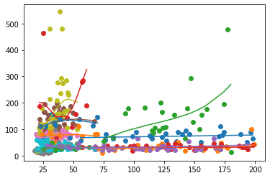

# actually imputing the missing data.

c = 1

value_to_count = 0

ground_truths = sel_cols

not_allowed = ['Outcome', 'Pregnancies', 'DiabetesPedigreeFunction']

original_df = df.copy()

from collections import Counter

for index, row in df.iterrows():

for col in df.columns:

# if a col is 0, then we want to predict it with the multiple models we have in our dictionary

if row[col] == 0 and col not in not_allowed:

amt, c = 1, 0

for tr in ground_truths:

# however, if one of our "ground truth" columns is zero, then exclude it from the predictors list

if (tr == col):

continue

if row[tr] != 0:

ss = tr + ' vs ' + col

amt *= mdls[ss].predict_single(row[tr])

c += 1

# find all the predicted values and then find their geometric mean

if (c > 0):

row[col] = amt ** (1/c)

C:\Users\sidha\AppData\Local\Temp\ipykernel_11660\1367550228.py:23: RuntimeWarning: invalid value encountered in power

row[col] = amt ** (1/c)

df.head()

|  | **Pregnancies** | **Glucose** | **BloodPressure** | **SkinThickness** | **Insulin** | **BMI** | **DiabetesPedigreeFunction** | **Age** | **Outcome** |
| --- | --- | --- | --- | --- | --- | --- | --- | --- | --- |
| **0** | 6 | 148 | 72 | 35 | 0 | 33.6 | 0.627 | 50 | 1 |
| **1** | 1 | 85 | 66 | 29 | 0 | 26.6 | 0.351 | 31 | 0 |
| **2** | 8 | 183 | 64 | 0 | 0 | 23.3 | 0.672 | 32 | 1 |
| **3** | 1 | 89 | 66 | 23 | 94 | 28.1 | 0.167 | 21 | 0 |
| **4** | 0 | 137 | 40 | 35 | 168 | 43.1 | 2.288 | 33 | 1 |

from sklearn.model_selection import train_test_split

from sklearn.preprocessing import StandardScaler

# preparing the data for model fitting

data = df.copy()

y = data['Outcome']

X = data.drop(columns=['Outcome'], inplace=False)

# scale the data

scaler_X = StandardScaler()

X = scaler_X.fit_transform(np.array(X))

X_train, X_test, y_train, y_test = train_test_split(X, y, test_size=0.4, random_state=42)

from sklearn.linear_model import LogisticRegression

import numpy as np

log_reg = LogisticRegression()

log_reg.fit(X_train, y_train)

  LogisticRegression[?](https://scikit-learn.org/1.4/modules/generated/sklearn.linear_model.LogisticRegression.html)i

LogisticRegression()

from sklearn.metrics import confusion_matrix

import seaborn as sns

import matplotlib.pyplot as plt

from sklearn.metrics import precision_score, recall_score, f1_score

# checking out the results with the imputed dataset

print("###################### Modified data results: ")

y_pred = log_reg.predict(X_test)

conf_matrix = confusion_matrix(y_test, y_pred)

plt.figure(figsize=(8, 6))

sns.heatmap(conf_matrix, annot=True, fmt='d', cmap='Blues', cbar=False,

xticklabels=['Predicted 0', 'Predicted 1'], yticklabels=['Actual 0', 'Actual 1'])

plt.xlabel('Predicted Label')

plt.ylabel('True Label')

plt.title('Confusion Matrix')

plt.show()

# Calculate precision, recall, and F1-score

precision = precision_score(y_test, y_pred)

recall = recall_score(y_test, y_pred)

f1 = f1_score(y_test, y_pred)

# Print or display the results

print("Precision:", precision)

print("Recall:", recall)

print("F1-score:", f1)

###################### Modified data results:

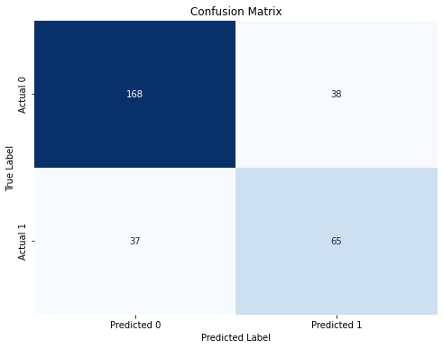

Precision: 0.6310679611650486

Recall: 0.6372549019607843

F1-score: 0.6341463414634146

from sklearn.model_selection import train_test_split

data = original_df.copy()

#now, doing the same but without imputed data

y = data['Outcome']

X = data.drop(columns=['Outcome'], inplace=False)

scaler_X = StandardScaler()

X = scaler_X.fit_transform(np.array(X))

X_train, X_test, y_train, y_test = train_test_split(X, y, test_size=0.4, random_state=42)

from sklearn.linear_model import LogisticRegression

import numpy as np

log_reg = LogisticRegression()

log_reg.fit(X_train, y_train)

  LogisticRegression[?](https://scikit-learn.org/1.4/modules/generated/sklearn.linear_model.LogisticRegression.html)i

LogisticRegression()

from sklearn.metrics import confusion_matrix

import seaborn as sns

import matplotlib.pyplot as plt

from sklearn.metrics import precision_score, recall_score, f1_score

print("###################### Modified data results: ")

y_pred = log_reg.predict(X_test)

conf_matrix = confusion_matrix(y_test, y_pred)

plt.figure(figsize=(8, 6))

sns.heatmap(conf_matrix, annot=True, fmt='d', cmap='Blues', cbar=False,

xticklabels=['Predicted 0', 'Predicted 1'], yticklabels=['Actual 0', 'Actual 1'])

plt.xlabel('Predicted Label')

plt.ylabel('True Label')

plt.title('Confusion Matrix')

plt.show()

# Calculate precision, recall, and F1-score

precision = precision_score(y_test, y_pred)

recall = recall_score(y_test, y_pred)

f1 = f1_score(y_test, y_pred)

# Print or display the results

print("Precision:", precision)

print("Recall:", recall)

print("F1-score:", f1)

###################### Modified data results:



Precision: 0.6310679611650486

Recall: 0.6372549019607843

F1-score: 0.6341463414634146

As can be seen, there isn't that much of a difference in these 2 runs of the model.

# Project Findings

The evaluation of the proposed polynomial regression imputation approach yielded insightful results. When comparing the performance of the logistic regression model trained on the original, incomplete dataset and the imputed dataset, there was no discernible difference in the classification metrics, such as accuracy, precision, recall, and F1-score.

This lack of improvement can be attributed to several factors:

1. Limited predictive power of the ground truth variables: The "ground truth" features ('Glucose', 'BMI', and 'Age') may not have possessed sufficient predictive power to accurately estimate the missing values in the other incomplete features.
2. Assumption of feature independence: In machine learning, it is often desirable to have independent features. The proposed approach did not induce bias by modelling the relationships between features; however, the assumption of interdependence between features is contrary to the desired characteristic of feature independence.
3. Varying predictive power of features: Some features may have had a stronger predictive power than others. While the computational effort expended in creating polynomial regression models for all feature combinations may not have been noticeable in this relatively small dataset (768 instances), it could potentially lead to disastrous consequences in larger datasets.
4. Numerical instability: The process of training multiple polynomial regression models and imputing values can introduce synthetic noise or instability into the dataset, potentially affecting the model's performance.

In comparison to traditional imputation methods, such as mean substitution, the proposed approach did not demonstrate a clear advantage in terms of improving the classification performance.

# Conclusion

The findings of this project highlight the situational nature of the proposed polynomial regression imputation approach. While the idea of leveraging the most complete features to estimate missing values in a nonlinear manner seems promising, its effectiveness heavily depends on the characteristics of the dataset and the predictive power of the available features.

In the case of the Pima Indians Diabetes Database, the ground truth variables ('Glucose', 'BMI', and 'Age') did not possess sufficient predictive power to accurately estimate the missing values in other features. Additionally, the assumption of feature interdependence, which is contrary to the desired characteristic of feature independence in machine learning, may have hindered the model's performance.

Furthermore, the computational complexity and potential introduction of synthetic noise during the imputation process raised concerns about numerical stability and efficiency. These factors, along with the assumption of feature interdependence, contributed to the lack of improvement in classification performance compared to using the original, incomplete dataset or traditional imputation methods.

While this project did not yield significant improvements in the specific context of the Pima Indians Diabetes Database, it provided valuable insights into the intricacies of missing data imputation and the importance of adhering to fundamental machine learning principles. The lessons learned from this exercise will inform future endeavors in data preprocessing and model development, emphasizing the need for careful feature selection, consideration of feature independence, and efficient computational approaches.

Moving forward, it is essential to tailor imputation strategies to the specific characteristics of the dataset and the problem at hand. Additionally, exploring alternative imputation techniques or combining multiple approaches may yield better results, especially in scenarios where the assumptions of this method are not met.